**Module 7: Docker with Microservices using Springboot -I**

Docker is a self-contained unit of software that can be delivered on any server having its own isolated process and has its own file system. We would want to further explore Docker before we choose it for the deployment of our microservices. Basically, we would like to check the feasibility of the deployment and ease of use to make an informed decision. So perform the below-mentioned tasks and share your findings.

1. Install Docker on a linux based machine (preferable Ubuntu-20).

2. Check Docker version

3. Launch Docker Hello World example

4. List docker images

Hint: Use a Linux machine for installing Docker.

Solution

Task 1 :

The first place to start is the [**official Docker website**](https://www.linkedin.com/redir/redirect?url=https%3A%2F%2Fwww%2Edocker%2Ecom%2Fget-started%2F&urlhash=idpJ&trk=article-ssr-frontend-pulse_little-text-block) from where we can download Docker Desktop.

### Step 2: Configuration

To run Linux on Windows, Docker requires a [**virtualization engine**](https://www.linkedin.com/advice/3/what-does-virtualization-engineer-do-skills-network-engineering-nunif?trk=article-ssr-frontend-pulse_little-text-block). Docker recommends using WSL 2

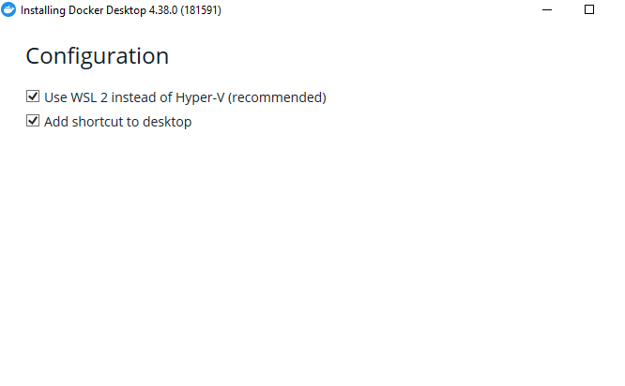

### Step 3: Running the instalation

Click Ok, and wait a bit…

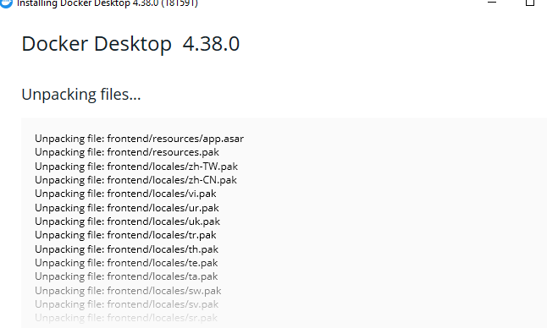

### Step 4: Restart

For Docker to be able to properly register with Windows, a restart is required at this poin

After the restart, Docker will start automatically and should see the window below:

Task 2 :

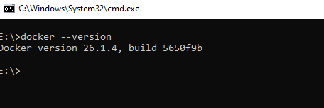

Task 3 :

### Pull the hello-world image

Now pull the hello-world image from docker use the below command:

docker pull hello-world

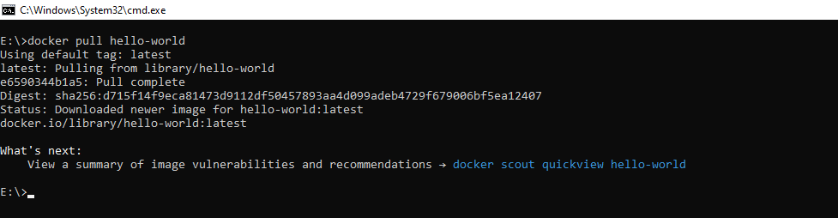

Command - **docker run hello-world**

Task 4 :

Command - **docker images**

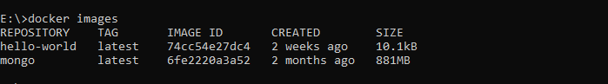

### Execute Hello world:

Use the below command to run the hello-world file in docker:

docker run hello-world

